International Conference on Advances in Sustainable Development, Innovation and Business (IC ADIB-26)
18th - 19th September 2026
Pre-Conference Workshop: 17th September 2026

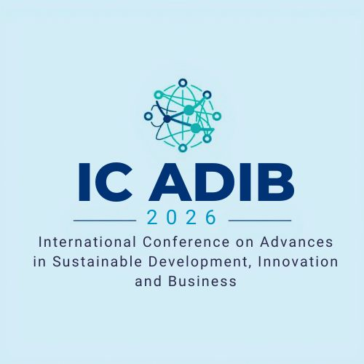

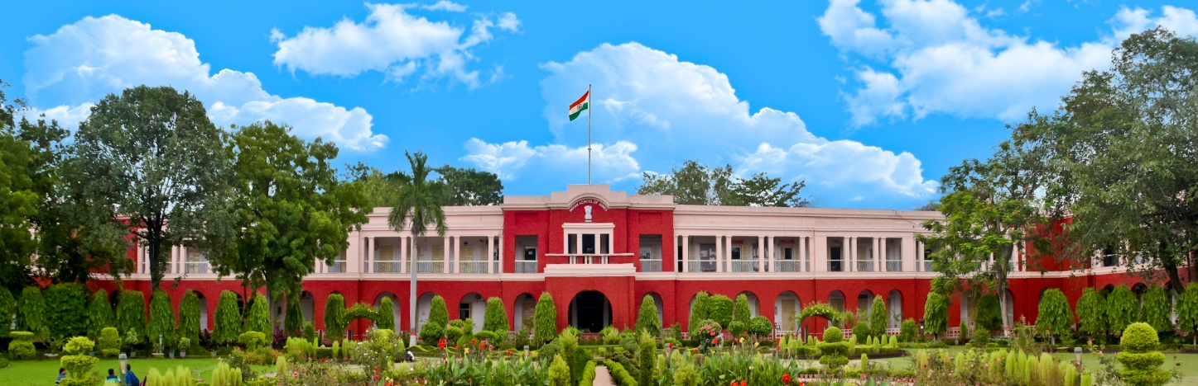

Organised by
Department of Management Studies & Industrial Engineering
Indian Institute of Technology (Indian School of Mines) Dhanbad

International Conference on Advances in Sustainable Development, Innovation and Business (IC ADIB-26)
18th - 19th September 2026
Pre-Conference Workshop: 17th September 2026

About the Conference
The International Conference on Advances in Sustainable Development, Innovation and Business (IC ADIB-26) aims to provide a global platform for academicians, researchers, industry professionals, policymakers and doctoral scholars to deliberate on the evolving role of sustainability in a digitally transformed world.
In the context of rapid advancements in digital technologies such as artificial intelligence, analytics, automation, and Industry 5.0, organizations are increasingly required to integrate sustainability, ethics, and responsible governance into their strategic and operational frameworks. This conference seeks to explore innovative management practices that balance economic performance with social responsibility and environmental stewardship. The conference will foster interdisciplinary dialogue, encourage evidence-based research, and facilitate knowledge exchange on how digital transformation can act as a catalyst for sustainable and inclusive growth across sectors.

About Indian Institute of Technology (ISM) Dhanbad
Established in 1926, IIT (ISM) Dhanbad is one of India’s premier institutions known for excellence in teaching, research, and innovation. Originally founded to cater to the mining and mineral sectors, the institute has evolved into a comprehensive technological university with global recognition. IIT (ISM) Dhanbad is committed to advancing knowledge through cutting-edge research, industry collaboration, and societal engagement. The institute actively promotes interdisciplinary learning and innovation to address complex challenges related to sustainability, technology, and economic development.

About the Department of Management Studies & Industrial Engineering, IIT (ISM) Dhanbad
The Department of Management Studies & Industrial Engineering at IIT (ISM) Dhanbad is a multidisciplinary department dedicated to developing future-ready management professionals and researchers. The department integrates management science, industrial engineering, analytics, and technology-driven decision-making. With a strong focus on research, industry relevance, and societal impact, the department emphasizes areas such as operations excellence, human resource management, finance, marketing. Through academic programs, executive training, and international collaborations, DMS&IE actively contributes to advancing responsible and innovative management practices.

Conference Tracks
The conference invites original research papers, conceptual papers, and case studies under (but not limited to) the following tracks:
- Track 1: Sustainable Strategy and Corporate Governance
- Track 2: AI, Analytics, and Digital Transformation
- Track 3: Sustainability, ESG, and Responsible Management
- Track 4: Human Resource Management and Future of Work
- Track 5: Marketing, Consumer Analytics, and Sustainable Value Creation
- Track 6: Operations, Supply Chain, and Industry 5.0
- Track 7: Finance, Accounting, and FinTech for Sustainability
- Track 8: Innovation, Entrepreneurship, and Startups
- Track 9: Public Policy, Governance, and Smart Cities
- Track 10: Global Business, Ethics, and Cross-Cultural Management

Call for Papers
The Organising Committee of IC ADIB-26 cordially invites original and unpublished research papers, conceptual papers, review articles, extended abstract from academicians, students, industry professionals, policymakers, and doctoral scholars. The conference aims to promote scholarly dialogue on how digital transformation, analytics, and emerging technologies can be leveraged to foster sustainable, ethical, and responsible management practices across industries and institutions. Those who do not want to send full paper may send extended abstract only.
Note: Full paper if accepted may be considered for publication in Scopus indexed journal. Extended abstract accepted and registered for presentation will be published in conference proceedings.
Important Dates (Tentative)
- Abstract Submission Deadline: 15th May 2026
- Notification of Abstract Acceptance: 15th June 2026
- Full Paper Submission Deadline: 15th July 2026
- Notification of Full Paper Acceptance: 30th July 2026
- Early Bird Registration Deadline: 15th August 2026
- Conference Dates: 18th -19th September 2026
- Pre-Conference Seminar: 17th September 2026
Conference fees & Registration
Type of participant | Early bird Registration Fees (+ GST @ 18 %) | Regular Registration Fees (+ GST @ 18 %)
Research Scholars/ Student | INR 4500 | INR 5500
Faculty Members | INR 6000 | INR 8000
Industry Participants | INR 10,000 | INR 12,000
International Participants | USD 200 | USD 250
International Participants (video conference only) | USD 150 | USD 200
Delegates/Accompanying Persons | INR 6,000
*Scholars/Students who only want to attend the pre-conference workshop can attend by paying the registration fee of INR 2500 + 18% GST. Pre- conference is free for those who have registered as a participant. Accommodation may be arranged on campus on a sharing basis/ single occupancy based on the availability of the Institute's Guest House / Hostels on payment basis.

Payment Details
The conference fees is to be submitted to the following account
IIT ISM CEP ACCOUNT
Account Number: 110261358281
IFS Code: CNRB0000986
Bank: Canara Bank
SWIFT CODE: CNRBINBBBFD

Internal Advisory Committee
Prof. Mritunjay Kumar Singh, Dean, Academic | Prof. Alok Kumar Das, Dean, Innovation, Incubation & Entrepreneurship
Prof. Rajni Singh, Dean, Corporate Communications | Prof. Rajeev Upadhyay, Dean, International Relations & Alumni Affairs
Prof. Sarat Kumar Das, Dean, Faculty | Prof.Parthasarathi Das, Dean, Research and Development
Prof. Amit Rai Dixit, Dean, Infrastructure, | Prof. Sunil Kumar Gupta, Dean, Students Welfare
Prof. J K Pattanayak (HAG) | Prof. Mohd Irfan
Prof. G. S. Pathak | Prof. Shikha Singh
Prof. Saumya Singh | Prof. Aparna Krishna
Prof. K. S. Thyagaraj | Prof. Rashmi Singh
Prof. Niladri Das | Prof. Sabnam Basu
Prof. Krishnendu Shaw | Prof. Aamna khan
Prof. Mrinalini Pandey | Prof. Esha Saha
Prof. Bibhas Chandra

Organising Committee
Chief Patron: Prof. Prem Vrat, Chairperson, BoG, IIT (ISM) Dhanbad
Patron: Prof. Sukumar Mishra, Director, IIT (ISM) Dhanbad
Co-Patron: Prof. Dheeraj Kumar Dy. Director, IIT (ISM) Dhanbad
Chairperson: Prof. Sandeep Mondal, HOD, DMS&IE
Prof. Himanshu Gupta | Prof. Shashank Bansal | Prof. Preeti Roy
Conference Convenor | Conference Co-Convenor | Organizing Secretary
himanshug@iitism.ac.in | shashank@iitism.ac.in | preetir@iitism.ac.in

For any queries icadib26@iitism.ac.in

Organised by
Department of Management Studies & Industrial Engineering
Indian Institute of Technology (Indian School of Mines) Dhanbad

